**Neighbors of Belknap Lookout Board Meeting**

**Tuesday, October 8, 2019**

**700 Clancy Ave NE**

**6:30 pm**

**Mission**: To advocate for and enhance the quality of life in the Belknap community.

**Vision**: To be a vibrant, diverse and desirable place to live in Grand Rapids.

**Public Space Goals**: Improving access down Belknap hill (design DDA budget FY2020); Hastings Connector & Linear Park (implementation City of Grand Rapids summer 2019 & 2020); Better Pedestrian Connections (MobileGR planning durable crosswalk and “stop for pedestrian” signs).

**Add’l Priorities**: Social Connections; Active in the Neighborhood; Voices Heard in Local Gov’t.

1. Call to order and additions to agenda
2. Upcoming Parking Changes on Trowbridge – Jon Re, City of GR + GRFD representative
3. Medical Marijuana at 49 Coldbrook – Ankur Rungta
4. Approval of September Minutes and Financials (Motion)
5. Officer Roles
6. Utilities and Minisplit
7. Miscellaneous & Public Comment
8. Adjournment

2019 Board Meeting Schedule, 6:30 pm

November 12 (Annual Meeting at East Leonard Elementary)

December 10 (Old board/new board potluck at 700 Clancy)

**Neighbors of Belknap Lookout Board Meeting Minutes  
Tuesday, September 10, 2019, 700 Clancy Ave. NE**

**Board Members Present:**

Loren Sturrus (President)

Robin Benton

Brian Bremer

Loretta Klimaszewski

Dean Rosendall

John Swets

Daniel Miller (Recorder)  
  
**Board Members Absent:**Todd Leinberger (excused)  
Rob Kennedy (excused)

**Staff Present:**Elianna Bootzin (Executive Director)

**Guests Present:**

Sean Forro   
Angel Gonzalez  
Terry Morris

1. **Loren called the meeting to order at 6:35pm.**

There were three additions to the Agenda:

1. RJM project
2. Feral cat spaying
3. Loss of parking on Hastings
4. **Board approved the Minutes of June 11 and August 13 meetings with minor clarifications as per Dean.**
5. **Board discussed Board member recruitment and nomination procedures.**
6. Loren is not eligible for another term due to term limits so we will need to elect a new Board President.
7. Two other places on the Board will be elected. Jon and Rob are eligible for reelection.
8. Board members were encouraged to look for potential board members and encourage them to express a willingness to be nominated by the October meeting. Elections will be held at the November meeting.
9. Elianna will have an orientation packet available at a session at 5:30 on the day of the October meeting to distribute to all potential candidates. It should include information on member obligations regarding regular attendance at meetings, monthly time commitment, volunteer service, and other expectations. Loren, Dan, and Loretta will constitute a Nominating Committee to determine whether to reduce the list of candidates to a slate for the number of openings.
10. **Board discussed the annual meeting in November.**
11. Pending issues that require neighborhood input or receiving information:
12. Marijuana dispensary on Coldbrook. C3 may make a presentation either at this time or sooner to ask for public comment.
13. Kendall College students will ask for public responses to their Park designs. (They will be getting initial input at the public meeting on September 17.) Neighbors, businesses and other allies will be able to take their finalized designs to the City Commission, Downtown Development Authority and similar bodies to advocate for completion of this major public work.
14. Someone from the City to discuss upcoming road construction plans in Belknap Lookout, with particular attention to the completion of the Hastings Connector.
15. An update from GVSU on their campus construction.
16. Other City representatives who could be there to talk to the public at tables prior to the meeting proper include Fire Safety, Fair Housing and/or Get the Lead Out, and GRPD.
17. Board discussed where to hold the meeting. Coit School and Finkelstein Hall were considered. Board voted to hold it at East Leonard School, pending availability, to make the meeting more accessible to residents who live at that part of the neighborhood.
18. **Miscellaneous items and public comment.**
19. Board discussed RJM development at SE corner of Clancy and Fairbanks. It will use three lots: two with houses that will be torn down and one that is owned by the Housing Commission which may require that some of the new units be “affordable housing” (no more than 1/3 of the income for a family at 80% of the area median income). NOBL Board can help to ensure compliance with that mandate. The Development Committee met with an RJM representative at its last meeting. The Development Committee offered a number of architectural suggestions about how to make the project more attractive to the neighbors but withheld approval until it saw more details of the project which the RJM representative said would be forthcoming at a future meeting.
20. C3 Industries wants to receive public comment prior to its Planning Committee meeting; possibly at the October meeting at 700 Clancy, or later. Loren told C3 that they are responsible to flyer the neighborhood to raise awareness of their interest in receiving public comment. Loren will find out when they will be on the Planning Commission agenda.
21. Loretta noted that feral cats are being neutered and given for adoption. Anyone who sees a feral cat can call Loretta at (616) 235-3846 to have it trapped and neutered.
22. GVSU work group members accepted the budget we submitted for the second round of PILOT funds at their June meeting. Elianna will contact Eric DeLong for follow up disbursement at the City Commission.
23. Angel expressed frustration at the City’s indifference to the concerns expressed by the NOBL Board in a letter to the City about the removal of 9 parking spaces on Hastings. He wished the letter had been strong but agreed that after the fact there was little that we could do. City representatives said the parking spaces were removed at the request of GVSU which wanted Hastings to be a “release valve” for traffic around Finkelstein Hall, presumably by adding turn lanes. Board expressed incredulity at the rationale since eliminating parking spaces while narrowing the street does not permit turn lanes or do anything to expedite traffic. On the other hand, the loss of parking has definitely harmed the prospects of businesses on the street including Rowsters Coffee and any other businesses that might have considered locating in the newly built retail space. Angel said we need to have a meeting with the City and the NOBL Board with local business representatives to discuss the decision making process. Terry said that the City is making these decisions in consultation with GVSU, Spectrum, and Rockford without letting the NOBL Board or anyone else know until it’s too late to have outside input. Often the decisions waive agreed upon parking space requirements. Loren noted that influential people in City government believe that we should be discouraging automobile usage by making it harder to park so people will walk, use bikes, and ride the bus. Angel asked: how do we make bus location? Loretta said that during the GVSU master plan meetings all they discussed was the ramp on Sinclair and College and took only limited input from the public. Loren and Elianna will make sure the Hastings conversation with the City moves forward.
24. Loren noted that the Bazzani project at Bradford and Lafayette is not “100 percent” due to radical changes in the design from what it showed the NOBL Board during the zone change. Loren told Economic Development that NOBL was simply “informed” of the changes they had made in the design. If the City does not approve an NEZ designation for the project, Bazzani may decide not to move forward on it.
25. Shaun Forro introduced himself as a real estate agent for Berkshire Hathaway. He does not currently represent any properties in the neighborhood but wanted to attend the Board meeting so he could get the latest on what’s going on in the area, the better to advise clients who may be looking to buy here.
26. Terry discussed his concerns about Highland Park.
27. He said that more homeless people are taking up residence in the park. He takes down brush where they hide. When discovered, they sometimes take refuge in the culverts which is dangerous because they could get stuck and there are rats. He calls the Police, but they don’t respond.
28. Terry is also painting the bridge which was covered with graffiti. He is almost done.
29. He also complained that trees planted in the park are not being maintained by the City and many are dying.
30. He also complained that the paths are overgrown and littered with rocks that it’s hard for walkers to use them. Someone needs to trim the brush at the side of the paths, it’s more than he can do. Loren suggested that he keep calling the City Parks Department since they’ve got more projects then they can complete so they tend to respond to “the squeaky wheel.”
31. He said brush is obscuring the frisbee golf course and there is no map to guide the players. Loren suggested he contact Bryan about that.
32. There is also lots of trash that’s not being picked up. He got trash bags from NOBL and has already removed 94 bags worth just in the last few months.
33. The storm drains are being blocked with dead leaves and trash which makes them overflow and creates a ravine that is getting bigger.
34. Loretta wondered what happened to the Parks Millage that City residents voted on. Isn’t any of it going to Highland?
35. Terry is also concerned that the new turnabout on Hastings and College. He thinks that the headlights of buses and cars will shine right into his house and he wants to have some input on the design.
36. **Meeting adjourned at 7:45 pm.**

**Respectfully submitted, Daniel Miller**

Meeting Information

1. Upcoming Parking Changes on Trowbridge – For safety reasons, including emergency vehicle access, the City of Grand Rapids is planning to change Trowbridge from Clancy to Prospect to one side parking only between now and November 1. Jon Re and a GRFD representative will provide additional context and details as well as answer questions.
2. Medical Marijuana at 49 Coldbrook: As previously discussed, C3 is under contract to buy the property at 49 Coldbrook for a medical marijuana dispensary. They hope to be scheduled for a public hearing at the December or January Planning Commission meeting. Their “good neighbor” plan includes hiring locally—up to 25 employees—and to maintain careful security at the property, including if need be a security guard. All products sold would be for medical, not recreational, purposes to start. After the state and city finish creating the rules for recreational marijuana, they expect to add that to their offerings. The purpose tonight is to get additional input from neighbors. Considerations raised at this meeting and the earlier presentation can be spelled out in a written agreement with NOBL to assure compliance.
3. Financials – The majority of the Neighborhood Leadership Contributions, Gifts and Grants are the Census minigrant ($5k, HWMUW) and the implementation funds for both NOBL and Highland Park as a result of completing the Neighborhood Leadership Academy ($3k total). These grants are primarily why we are running a surplus in that program. Most other programs are falling just around breakeven. By the time we meet, our assets and liabilities should be adjusted to have value of land at the end of our depreciation curve and a re-balanced withholding amount for employee taxes.
4. Officer Roles – We left definition of officer roles out of our Bylaws revision last year. We did set the Chair as the person responsible for oversight of the Executive Director between meetings. We also set the officers as the small group to handle a temporary change in Executive Director while the entire board would set a Transition and Search Committee for a permanent change. I would propose as well that the officers should be authorized as a group to finalize letters the board has requested to send for a streamlined process. As has been operationally true, all officers can sign checks as well.

The following text is proposed as a board policy to be considered along with the Bylaws:

The officers of the NOBL board shall be a chair, vice chair, secretary, and treasurer. As a body they may 1) serve as the small group to handle a temporary change in Executive Director, and 2) be authorized to finalize letters the board has requested to send. As individuals, they may sign checks and contracts as well, though in both cases these will likely fall to the Chair and/or the Treasurer.

1. The Chair may take reports from the Executive Director between meetings and will compile input from the board for the Executive Director’s annual review. The bulk of the Chair’s regular responsibilities have to do with running board meetings, at which he or she will:

* Call the meeting to order at the appointed time and announce items on the agenda in the proper order.
* Recognize those who wish to speak in proper order; protect the rights of the person speaking and maintain decorum.
* Clarify all motions that have been made and seconded, so that all have heard and understand the motion before calling for a vote.
* Vote only in case of a tie.
* State definitively and clearly the result of the vote.

The Chair and the Executive Director may both make public statements (primarily for news media) for the organization and should keep each other informed of what they have said.

B) The Vice Chair should familiar with the duties of the Chairperson and be prepared at all times to assume that office.

C) The Treasurer should work with the Executive Director to determine updates to financial procedures, with a likely goal of reviewing monthly bank statements and financial reports. This individual can also take the lead on the discussion of the financial reports at each board meeting as well as take part in the preparation and presentation of the budget around the end of the year and the 990 after the year end.

D) The Secretary should keep careful and authentic records of development proceedings and all motions. General discussions may be summarized with emphasis on the overall conclusion, and only highlights of the pros and cons discussed. The minutes should be shared with the board, via the Executive Director if desired, within 2 weeks of the meeting.

Are there any duties you would like to see added or removed? Do any of these statements inspire you to suggest a better description of any other division of labor?

1. Utilities and Minisplit – The upstairs apartment’s minisplit has been more reasonable in terms of costs in the summer than the winter. This change corresponds with the fact that there is a smaller temperature differential in the summer than the winter. Elianna’s main thought was to see if we need/can add insulation between tenants this winter. Is there anything else we should change physically? Where should we advertise? Etc.

**Regular Report Contents:**

Crime (last four weeks) from   
[www.crimemapping.com](http://www.crimemapping.com)

Fire from [https://grandrapids.maps.arcgis.  
com/apps/View/index.html?appid=50bbc7410e5447b99edde0e32d62f4c4](https://grandrapids.maps.arcgis.com/apps/View/index.html?appid=50bbc7410e5447b99edde0e32d62f4c4) (one week)

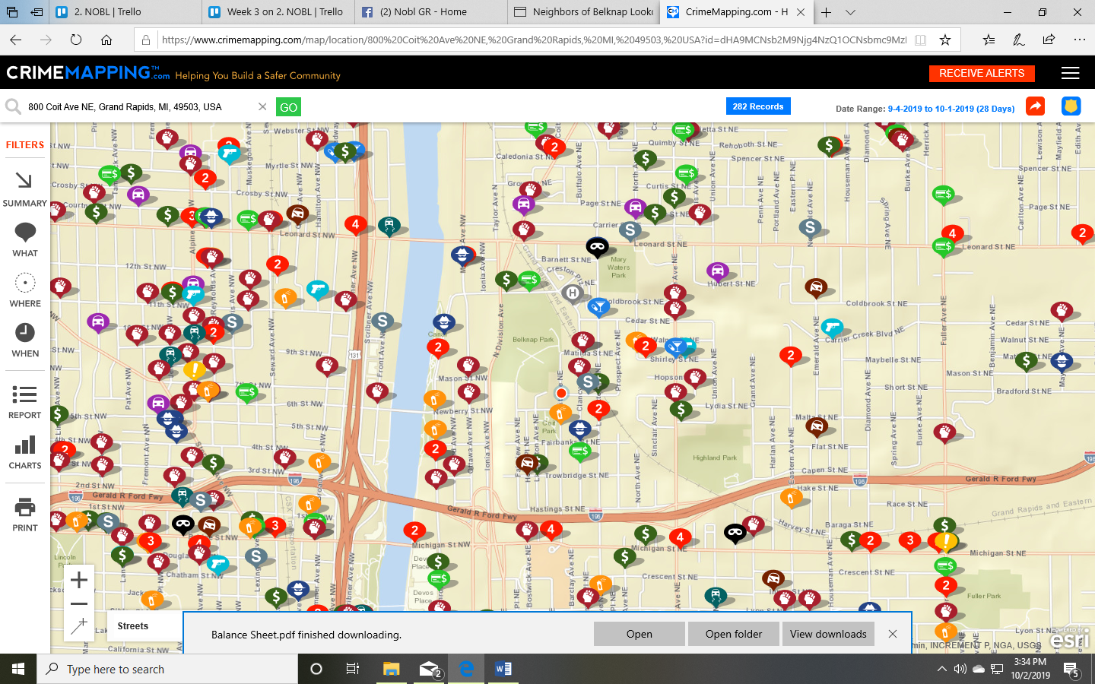 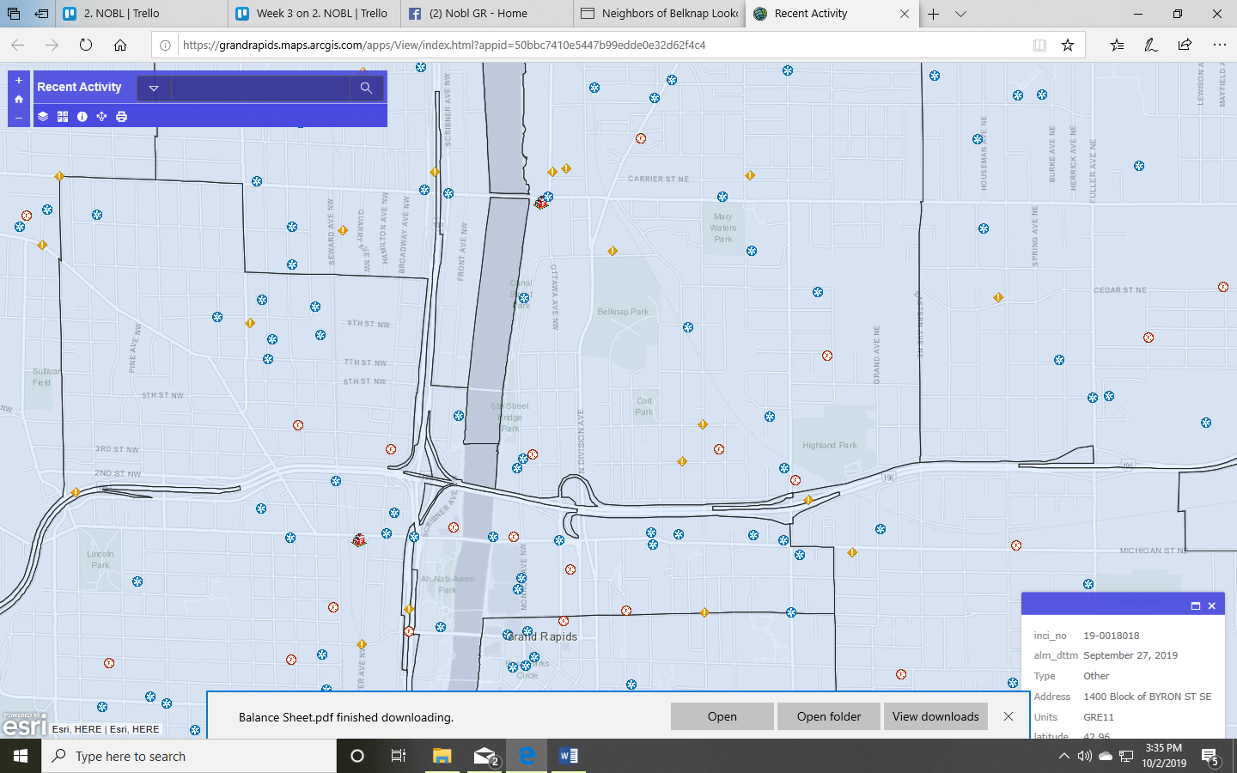

**Public Safety:** The hardcopy fall newsletter is focused on public safety, providing information on preventing the most common crimes that took place in the neighborhood this summer.

**Updates on Old Business:**

* No further updates on 712 North, office signage, HousingNOW, trash can at L&L or lighting on stairs.
* We do know in general that buying 762 North will need to wait at least a couple of months.
* Work plan really feels like a moving target right now. Determined with GRPD trainer that getting to individual discussions to see what residents want to learn and affect is going to drive the home safety side of things. Getting back to telling businesses about fire self-inspection will help with public safety.

|  |  |  |
| --- | --- | --- |
| Our current performance on CDBG Outcomes/Indicators | YTD (1/4) | Goal |
| # received training - personal safety for home | 5 | 92 |
| # reported feeling safer | 4 | 69 |
| # receiving safety improvements | 1 | 4 |
| # educated on public safety design features | 2 | 60 |
| # places where public safety implemented | 0 | 1 |
| # significant public safety issues IDed | 1 | 4 |
| # significant issues resolved >6 months | 1 | 4 |
| # receiving leadership training. | 3 | 43 |
| # report > knowledge about leadership | 1 | 32 |
| # became involved in board or committee. | 3 | 15 |
| # who improved a neighborhood condition | 8 | 185 |
| # owners contacted about nuisance and/or exterior code | 0 | 35 |
| # issues resolved thru self-compliance. | 0 | 15 |

* Highland Park – The Family Fun Day with Disc Golf tournament was only lightly attended. Terry reported cleaning up more trash, etc.
* Hastings follow up: Elianna met with Angel, DTN rep, and City staff. The first update is that the retail parking zone will expand slightly to having room for, I believe, a total of 8 cars on Clancy and 4 cars on Coit. This expanded zone will stay within the footprint of the Gateway property. MobileGR also reports that not all residential permit parking zone spots have been purchased. There will be pay stations going in too. The next stage, paid by DTN, will be curb cuts with porous pavers on Hastings to add another 8 parking spaces.

That area will also get better signage for the parking behind the building.

Doing anything on south side of Hastings is a long shot since the Linear Park takes precedence, but it sounds like Colin will at least look into it briefly.

* Our PILOT funds should be up for disbursement at the City Commission meeting on October 8th.

**Other area news:**

* The road diet for Michigan Street is finally on its way: "Improved safety is the focus of upcoming changes to the traffic signals and pavement markings along Michigan Street NE. Crews will conduct the Michigan Street NE lane reconfiguration project from College Avenue to Diamond Avenue on Saturday, Oct. 5. Work will be pushed to Saturday, Oct. 12 if there’s inclement weather." – City of Grand Rapids
* The City’s Task Force on Elected Representation is inviting community members to share their thoughts on several citizen-led initiatives to change the way residents are represented on the City Commission and how officials are elected or appointed (including even vs odd years, and 8 vs 3 wards). The community-led task force is holding a 2nd Ward feedback sessions on Oct. 10 from 6 to 8 p.m. at Grand Rapids Public Schools University, 1400 Fuller NE
* The City is removing overhead primary conductors from Sinclair over the highway:   
    
  https://grandrapidscitymi.iqm2.com/Citizens/Detail_LegiFile.aspx?Frame=&MeetingID=5350&MediaPosition=&ID=9864&CssClass=
* The City will adopt a recreational marijuana ordinance, to take effect 6 months later, on Oct 8. At the end of those 6 months, the City would begin accepting applications for recreational marijuana businesses. The City Commission needs to adopt an ordinance no later than Nov. 1 to avoid a default opt-in status while lacking reasonable regulations on marijuana uses.

The ordinance provides an important tool by which the City can follow up on agreements made by the applicant during the application and review process, for enforcement actions if needed.   
  
https://grandrapidscitymi.iqm2.com/Citizens/Detail_LegiFile.aspx?Frame=&MeetingID=5350&MediaPosition=&ID=9872&CssClass=