**Neighbors of Belknap Lookout Board Meeting**

**Tuesday, January 14, 2020**

**NOBL Office, 700 Clancy Ave NE**

**6:30 pm**

**Mission**: To advocate for and enhance the quality of life in the Belknap community.

**Vision**: To be a vibrant, diverse and desirable place to live in Grand Rapids.

**Public Space Goals**: Improving access down Belknap hill; Hastings Connector & Linear Park; Better Pedestrian Connections.

**Add’l Priorities**: Social Connections; Active in the Neighborhood; Voices Heard in Local Gov’t.

1. Call to order and additions to agenda
2. 614 Fairview – CopperRock
3. Approval of December minutes and year end financials
4. Choose officers; fill out updated bank forms
5. CDBG grant requirement: Select a committee to complete a 2020 employment agreement, or determine the amount of 2020 paid time off
6. Fill out conflict of interest surveys
7. Approve 2020 budget
8. Create work groups and schedule meetings for relevant 2020 activity items
9. Miscellaneous & Public Comment
10. Adjournment

Homework: Consider whether you wish to fill the vacant board slot, and if so whom you would recommend appointing for the remainder of the year or the two years left in the term.

2020 Board Meeting Schedule, 6:30 pm at 700 Clancy Ave NE:

February 11

March 10

April 14

May 12

June 9

July 14  
August 11

September 8

October 13

November 10 (Annual Meeting at Coit Creative Arts Academy)

December 8 (Old board/new board potluck)

Neighbors of Belknap Lookout Meeting Minutes

Tuesday, December 12, 2019

**Members Present:**

Loren Sturrus (President)

Elianna Bootzin (Executive Director)

Brian Bremer

Rob Kennedy

Loretta Klimaszewski

John Swets

Daniel Miller (Recorder)

**Members Absent:**

Robin Benton

Todd Leinberger

Dean Rosendall

**Guests Present:**

Amy Gautraud (Board Member-elect)

Kara Harrison-Gates (Board Member-elect)

Chris Swank (GVSU rep)

Melinda Ysasi (GR City Commissioner-elect)

1. The meeting was called to order by Loren at 6:30.
2. Melinda Ysasi introduced herself and answered questions. She speculated that that the reasons several upper level City employees have left may be due to wage competition, a natural response to a new city manager, a strong job market. Good people are serving as interim replacements and there are many good candidates to replace those who have left. The difficult positions to fill are those that require specialized technical skills.
3. October 6 and November 9 Board minutes and January to November financial statements were approved.
4. Board discussed concerns about the heating costs of 700 Clancy. Last January, the upstairs unit paid $250 for heat which NOBL paid. Elianna said the basement rimjoists could be insulated, a hole could be plugged, and the windows caulked for $1000. Insulating the basement walls would cost $3500 and could be put off for now. After discussing the “mini-split” and the basement heater, several Board members went down to the basement to check out the space. Discovered that some of the furnace’s duct work was not completely installed. Loren will try to get a lower quote for needed insulation. Elianna will contact BelAir to fix defective work.
5. Board discussed highlights of 2019. Successes included:
6. Community Garden
7. Cat sterilization program.
8. Well attended meeting at East Leonard and useful comments from architects about Copper Rock project at 835 Fairview.
9. Good meeting space at Newberry Place.
10. Board discussed concerns of 2019.
11. Need for more neighborhood involvement. (GVSU will pay the cost of one printed flyer for distribution so that could help inform neighbors.)
12. “Next Door” has been hard to access.
13. Need to find additional sources on non-allocated funds. Elianna will solicit funds from long-time supporters. Kara suggested seeking donations from neighborhood businesses. (C3 Industries indicated that they would provide some funding.) DTN paid to move the Charles Belknap statue to and install benches at Coit and Hastings.
14. Trash cans have been moved from parks for the winter. Trash cans at bus stops are not maintained by The Rapid. Amy is taking care of one in her neighborhood. We need to find more partners to help empty them.
15. Board discussed goals and projects for 2020.
16. Jon wants a bike trail from Grand Avenue to Lafayette and Plainfield to be constructed along the Railroad tracks. Loretta noted that the railroad company will object due to liability issues.
17. Loren wants to see Coldbook Creek “daylighted.”
18. Loren wants to see stairs at Fairbanks and at Bradford to be repaired and lighted.
19. Loretta wants to see someone at the city mow and maintain the areas around those stairs since this year Parks and Streets departments argued over responsibility and they were only mowed one time in October.
20. Loren would like to see a neighborhood market like the one at Midtown. The defunct gas station at Bradford and Lafayette would be a suitable venue if it could be cleaned up with the help of state brown site funds. Feeding America might be willing to donate some produce.
21. Jon thinks a beer tent would work well there as part of the market.
22. Loretta would like NOBL to get a 50-year lease from the Michigan Land Bank for the 762 North Street garden site rather than buying it so we wouldn’t have to pay property taxes on it. It would also be good if we could have a water source on the site.
23. It would be good to do some alley clean up, litter pick up, and to check up on sidewalk snow removal.
24. Elianna reminded the Board that proposed projects must satisfy Public Safety and Community Development criteria if they require allocated funds.
25. The NOBL intern is compiling data on the racial and economic characteristics of Belknap Lookout and is presenting it in brochures and posters.
26. Board discussed poker night fundraising. NOBL netted $1700 from the recent Casino Nights at Westgate but it was hard to get volunteers to fill the late-night spots. Board members need to do a better job of recruiting volunteers and players. NOBL should investigate whether it can pay Elianna to work on poker nights. Perhaps it would be better to schedule poker nights at Russo’s on south Division since they operate during the day rather than at night like Westlake. Kara suggested that we might be able to get a larger “cut” from them in view of their need for non-profit partners.
27. We need to grow our email list.
28. Neighbors who want to make use of community garden will continue to be encouraged to “buy-in” by paying a $20 “suggested donation” and by agreeing to a work commitment such as weeding.
29. Community News.
30. Loren reported that the C3 Industries application for a marijuana dispensary on Coldbrook has received objections from a local church.
31. Hester Alley has been torn up to repair a broken sewer.
32. Meeting adjourned at 8:20 pm.

Respectfully submitted, Daniel Miller

Correction to November Minutes

Alan Otis said there were 2 improvements that he applauded from the original plan: lower density and a better design than that of Dean’s ‘shed roof’ concept, not ‘many'. While he did say he expected it would not ‘wear well’, he also offered a number of criticisms and closed by saying it was a ‘bad design.’

Meeting Information

1. 614 Fairview, CopperRock: The Development Committee approved this project in May.

Project overview: The Development Committee met with Dean Rosendall of CopperRock Construction twice before agreeing to bring the site plan and elevation drawings for two buildings at 614 Fairview with a total of 5 units and 7 parking spaces to the board.

5/8 Meeting Notes (attended by Rob Kennedy, Rob Montroy, Gretchen Warnimont, Don Rietema, Brian Bremer, Dan Miller, Loren Sturrus, Angel Gonzalez, and Elianna Bootzin). The lot is 75’ wide (most are 50’ or less). 606 next door is taller. The group preferred both buildings at 2.5 stories. One will have a garden level option. They are likely to be condo-ed. Trash logistics were still TBD. The group asked that the dormer be fixed and to see something more traditional for the northern building than the original drawing. The porch will be 8 feet. The existing 3200 sq ft house is in bad shape and has asbestos siding. It would be difficult to sell as a single unit and fire separation needed for splitting to more units. The new set backs are 7’ on each side, and the property will still have 40% greenspace. The existing garden would also be hard to save. The group agreed the density is fine and looked forward to a second meeting with aesthetic revisions.

5/15 Meeting Notes (attended by Rob Kennedy, Rob Montroy, Gretchen Warnimont, Don Rietema, Dan Miller, Loren Sturrus, and Elianna Bootzin). The group reviewed three revision options. The balcony is 6-8’ deep and about 25’ wide. The porches would be brick and stone. Board and batten would be used on the top of the southern building. Don recommended holes at the front of the porch. The north building will have all 2 bedroom units, about 1100 sq ft each. Dean clarified the building alignment and mentioned he will place a sign indicating there will be future development. The materials from the front will wrap around and there will be windows on the sides. The group chose the version with columns on the bottom but not the top and agreed to bring it forward to the board. We set a standing meeting pattern.

1/8 Meeting Summary (More details available later upon request): The group agreed to bring both the traditional (May) version and a new brownstone variation to the board.

1. Choose officers; fill out updated bank forms: Our bylaws call for a chair, vice chair, secretary, and treasurer. The chair and treasurer selected today, as well as the Executive Director, will be authorized as signatories on our accounts at Lake Michigan Credit Union and Bloom Credit Union. [Fill out LMCU form and copy driver’s licenses.]
2. CDBG grant requirement: Select a committee to complete a 2020 employment agreement, or determine the amount of 2020 paid time off. If you wish to carry last year’s arrangement forward, the details are: 3 weeks of vacation/sick day credit plus NOBL’s 8 paid holidays: New Year’s Day, Memorial Day, Independence Day, Labor Day, Thanksgiving Day and the day following, Christmas Eve or New Year’s Eve, or 1/2 day for each, and Christmas Day.
3. Fill out conflict of interest surveys: We collect statements from all board members annually. Our policy reflects that individuals affiliated with competing real estate projects should not vote on project endorsements to avoid the appearance of a conflict of interest, as well as the basic exclusion from participating in selecting one’s own company for a vendor transaction.
4. Approve 2020 budget: This budget expects a slight increase in Program Service Revenue as we increase rent to $650 for the later portion of the year when we have a new tenant. Wages will be somewhat higher due to hiring a temporary part time staffer from February to May with Census minigrant funds from the Heart of West Michigan United Way. This budget takes into account a new “Directors and Officers” insurance policy, which is an important investment given our interaction with so many development projects. Finally, the service fees are for the loan for the minisplit. Expenses follow on the next page:

|  |  |  |  |  |
| --- | --- | --- | --- | --- |
| **2020 NOBL Budget** | |  | |  |
| **Income** | |  | |  |
| Contributions, Gifts & Grants | | $ 21,000.00 | |  |
| Gaming & Fundraising Events | | $ 6,000.00 | |  |
| Interest Income | | $ 20.00 | |  |
| Program Service Revenue | | $ 6,850.00 | | Bump rent to $650 |
| CDBG | | $ 35,300.00 | |  |
| **Total** | | **$ 69,170.00** | |  |
|  | |  | |  |
| **Expense** | |  | |  |
|  | |  | |  |
| *Salaries & Related Expenses* | |  | |  |
| Unemployment Insurance | | $ 75.00 | |  |
| Wages | | $ 34,500.00 | | Census |
| Employer FICA | | $ 2,500.00 | |  |
| Worker's Comp Insurance | | $ 319.00 | |  |
| *Salaries & Related Expenses Subtotal* | | *$ 37,394.00* | |  |
|  | |  | |  |
| *Occupancy* | |  | |  |
| Building Maintenance | | $ 1,000.00 | |  |
| Utilities | | $ 2,250.00 | |  |
| Property Taxes | | $ 2,605.00 | |  |
| Telephone Internet | | $ 1,200.00 | |  |
| Other | | $ 3,131.89 | |  |
| *Occupancy Subtotal* | | *$ 10,186.89* | |  |
|  | |  | |  |
| Supplies | | $ 600.00 | |  |
| Postage | | $ 400.00 | |  |
| Printing and Pub | | $ 800.00 | |  |
| Accounting/Payroll | | $ 530.00 | |  |
| Training | | $ 1,000.00 | |  |
| Insurance | | $ 1700.00 | | Add D&O |
| Service Charge | | $ 550.00 | | Loan |
| Special Events Expense | | $ 3,100.00 | |  |
| Other | | $ 600.00 | |  |
| Neighborhood Improvement | | $ 11,650.00 | |  |
| **Grand Total** | | **$ 68,510.89** |
|  | |  |
| Net Rev (Loss) | | $ 659.11 |
|  |

1. Create work groups and schedule meetings for relevant 2020 activity items

**Top priority infrastructure:**

Belknap Hill: Evaluate comments on KCAD designs and determine course of action for advocacy

Hastings Connector & Linear Park: Communicate about summer 2020 construction

Find new service that will work inside pit meters for irrigation turn on/turn off

Better Pedestrian Connections: Request information from MobileGR about where durable crosswalks and pedestrian in crosswalk signs will go?  
Facilitate request for traffic calming evaluation on Fairview (reserve PILOT traffic calming $)

**Future priority infrastructure:**

Bike Trail (Jon): Adam Williams is researching; will either report out or have group in March.

Development of Lafayette: Neighborhood Market/Food Project (Kara) or Beer Tent (Jon)

**PILOT projects:**

Beautification: Planting (Jon)

Lighting on Stairs (Dean)

Repair Bradford Stairs

Mow by Bradford Stairs: Ask streets and parks to ensure it is on someone’s list

Buy/Lease Garden: MI Land Bank update from Kara?

Operate Garden: Loren contact for water

Choose Improvements for Garden:

Cats (Loretta): Meet to determine how to expand to more parts of the neighborhood

Communication: Fall postcard

Events: $600 Board food

$500 National Night Out

$500 Annual Meeting

$200 40th Anniversary Open House (March 26, noon to 8 pm at 700 Clancy)

$ 45 other event snacks

Trash cans: May need to replace one at Hastings and Coit?

**Social: Add 30-60 email contacts**

Encourage house parties to celebrate 40th anniversary (also fundraising opportunity)

Spring/Summer park activities (low key, yard games, facepaint, etc.)

5 potlucks: Feb, Apr, Jun, Aug, Oct

**Building Maintenance:**

Duct repair ($200 with BelAire)

DIY basement insulation (Loren)

DIY window caulking

**Organizational Documents:**

Internal Controls

Cost Allocation Plan

Board Discussion Topic List

**Other:**

Ask GVSU to extend Tenant Relocation Protocol

Coldbrook Creek daylighting: Connect with appropriate groups; considering joint grant application with Grand Valley Metro Council

**Regular Report Contents:**

Crime (last four weeks) from   
[www.crimemapping.com](http://www.crimemapping.com)

Fire from [https://grandrapids.maps.arcgis.  
com/apps/View/index.html?appid=50bbc7410e5447b99edde0e32d62f4c4](https://grandrapids.maps.arcgis.com/apps/View/index.html?appid=50bbc7410e5447b99edde0e32d62f4c4) (one week)

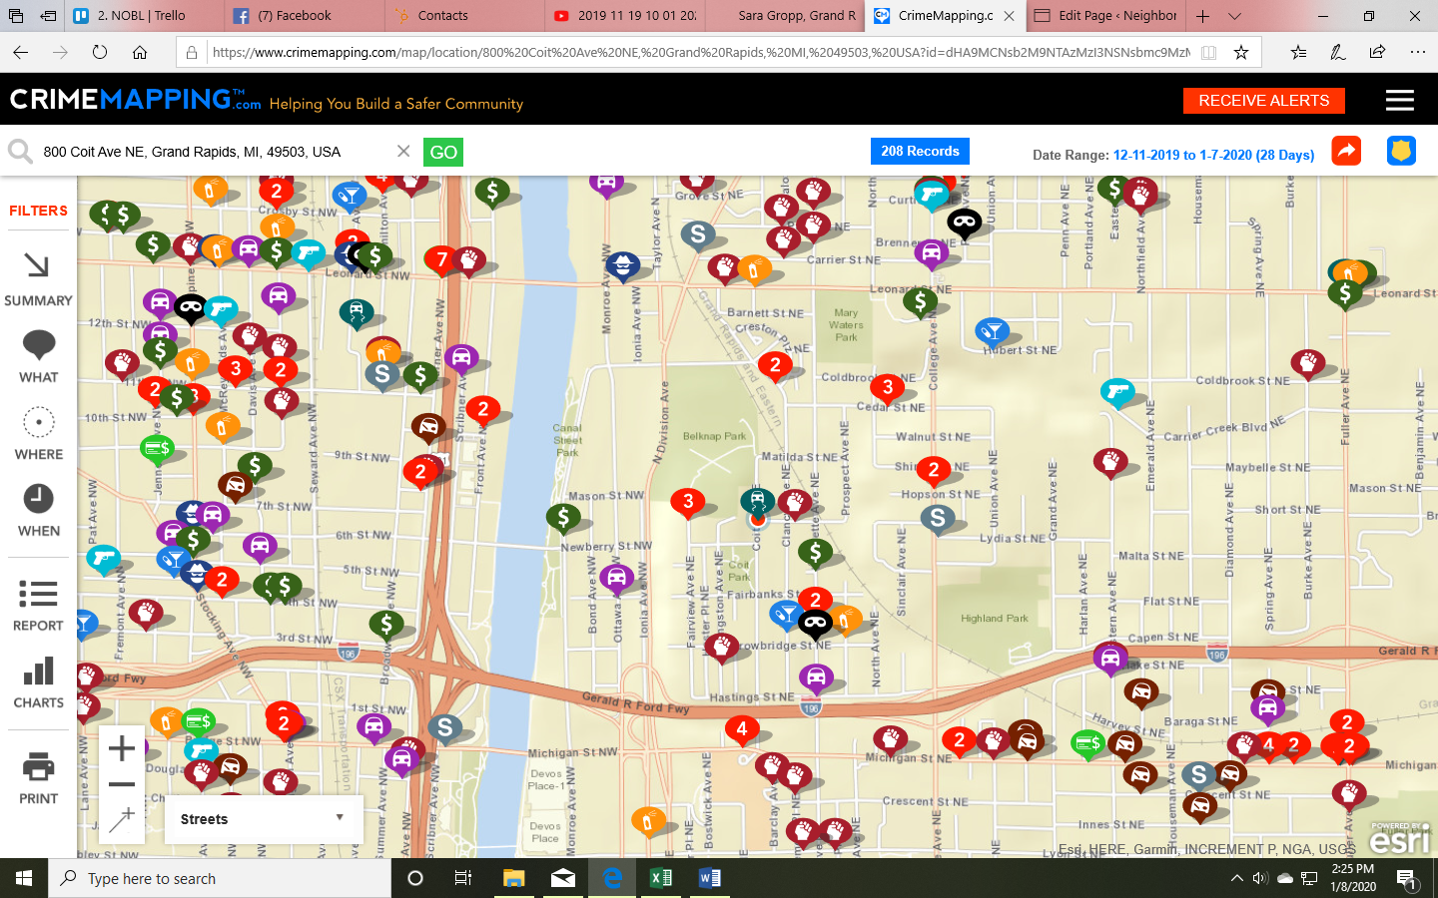 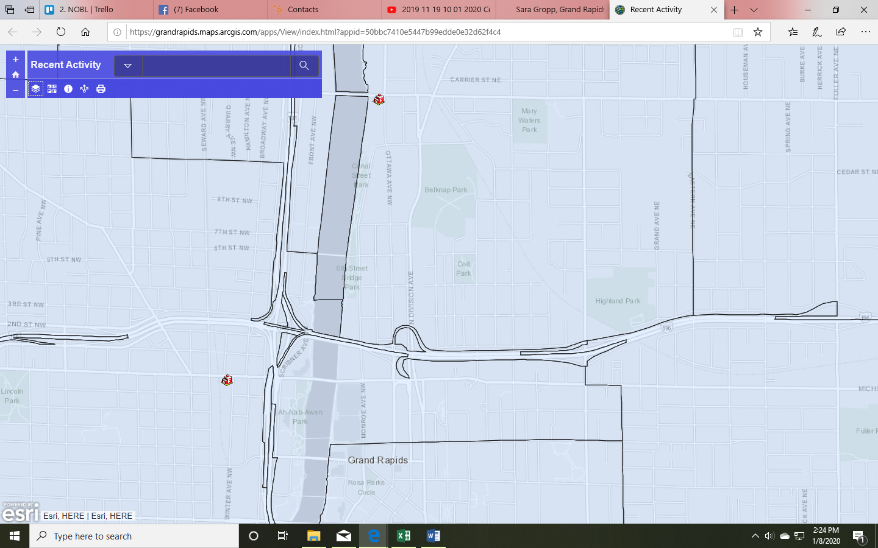

**Public Safety:** Phone calls to neighbors in December emphasized the safety impact of shoveling.

**Development:**

* January 8 hearing for 49 Coldbrook marijuana facility resulted in no park waiver.
* We should have results from the January 9 hearing for 835 Fairview at the meeting.

**Updates on Old Business:** No further updates on 712 North, office signage, HousingNOW, trash can at L&L or lighting on stairs.

**Other NOBL updates/use of staff time:**

* We're at the top of the list for filling cancellations at Kings Poker room (S Division)

**Other area news:** Bradford Station broke ground at Bradford and Lafeyette.