**Neighbors of Belknap Lookout Board Meeting**

**Monday December 13, 2021, 6:30 pm on Zoom:**

[https://us02web.zoom.us/j/84768261679?pwd=dURQczVTcFIzMCt5Z3FScFh6MkhpZz09](https://www.google.com/url?q=https://us02web.zoom.us/j/84768261679?pwd%3DdURQczVTcFIzMCt5Z3FScFh6MkhpZz09&sa=D&source=calendar&usd=2&usg=AOvVaw00fLWxzNF-azl9__-T74k1)

**Need to connect by phone? Dial by your location**

**+1 646 558 8656 US (New York)**

Meeting ID: 847 6826 1679 Passcode: 192712

**2021-2024 Statements**

**Mission**: To empower residents of the Belknap neighborhood to identify their interests, support their own well-being, and to facilitate community health and prosperity.

**Vision:** A neighbor driven organization, committed to making a deep impact on the major institutions around us and collectively improving our built environment and our neighbors’ quality of life.

**Values: Justice Community Quality of Life Accountable**

**COMMUNITY STANDARDS:**

• When there is a disagreement acknowledge the other’s viewpoint by restating what you believe they are saying.

• Be considerate.

• No attacks.

• Be constructive.

• Assume good intent.

• Check your privilege.

• Step away if you need to

• Bring to the table the point of view of those who are not represented.

• Allow for leaning/be aware of your own triggers.

• Lean in if you tend to speak less, lean back if you tend to speak more.

**Agenda**

* Roll Call
* Last Month’s Minutes
* Talk about each area of the Strategic Plan
* Subcommittees
* Guests
* Miscellaneous

**Meeting Details**

* Roll Call   
    
  Old board:  
  Dan Miller (chair)  
  Ellie Walborn-Henry (vice chair)  
  Amy Gautraud (treasurer)  
  Kara Harrison Gates  
  Sheri Munsell  
  Loren Sturrus

Presumptive new board:  
Cassidy Cvanciger  
Marshall Grate  
Scott Huebl  
Adam Rogalski  
Will Witt  
  
Review 5 Finger Polling Method  
Who has standing to vote?

Finalizing terms

- Last Month’s Minutes  
  
**Neighbors of Belknap Lookout Meeting Minutes**

**Monday, October 11, 2021, Zoom Meeting**

**Members Present:** Dan Miller Kara Harrison Gates   
Sheri Munsell

**Staff Present:** Elianna Bootzin (Executive Director)

Gregory Retzlaff (MSW intern)

**Guests Present:** Chris Swank (GVSU Representative)

1. Meeting contents began at 6:40 pm. Ellie Walborn-Henry and Amy Gautraud indicated via text that they are alright with the action items.
2. Chris Swank reported that construction has begun on the mixed income apartments behind Finkelstein Hall. Overflow parking into the neighborhood should be reduced. We will discuss the 8 houses proposed for demolition later in the meeting.
3. Elianna moved ahead to the report on Justice items.
   1. We will walk back our commitment to paying committee members and start trying to raise funds for those positions by soliciting businesses including the MNBA, We will check for Special Events funds at the City next spring/summer. We may consider lobbying for TIF financing in the future.
   2. Kara asked that we postpone approving the Scorecard to December.
   3. Demographic goal revised to indicate we welcome business participation.
4. Minutes are approved as read.
5. Community Action Items:
   1. We will not take any direct action on alley lighting. We will educate potentially interested home owners in the spring newsletter, with a focus on 311 phone or app for burned out lights.
6. Quality of Life:
   1. GVSU: Karen did not attend with details so Elianna will ask Chris to forward her email about the houses. This item will be on the December agenda.
7. Accountable:
   1. Elianna reviewed the quarterly financials, which were approved.
   2. The Conflict of Interest Policy will move to December.
   3. The board approved a $950 budget amendment for drywall and a $341 budget amendment for property insurance.
   4. The board is interested in continuing poker events and supports identifying a core set of volunteers before scheduling events.
   5. Kara will assist with selection of Property Management.
   6. Chris Gates can assist with Cyber Insurance preparation. We can also send it to David Marquardt for guidance.
8. Miscellaneous:
   1. Elianna will ask Marshall for an update on the Belknap Hill project (he attended a discussion with the DDA’s contractors).
   2. We are the fiduciary for a neighborhood match fund grant in place of East Hills.
   3. Elianna will include Sheri on her RSVP to the GVSU’s Interprofessional Center if she is available.
   4. Board members are encouraged to attend the November Racial Equity meeting since there is no November Board Meeting and our 2nd ward commissioners will be the guests for that event.

- Talk about each area of the Strategic Plan (ACTION ITEMS)

Justice

Approve Scorecard –

Based on the presentation from Kymie Spring on the Climate Resolution Coalition at the October Racial Equity Committee meeting, that body recommends adding a point for providing a Sustainability Plan.

<https://www.belknaplookout.org/wp-content/uploads/2021/09/NOBL-Community-Development-Scorecard.pdf>

Approve Representation Goal - to have some representation from 6 of the following: African American, Hispanic, LGBT, female, multigenerational, renter, disability. We welcome representation from businesses as well.

Neighbor comments: This is a proactive goal and one that I support. Of course, we also want to be sure that we’re not just adding individuals to the Board because they represent these target groups. We need people who are committed to making NOBL a community that stands strong, together in the face of adversity and triumph.

Quality of Life

GVSU – Demolition (the board already took action without a meeting to issue concurrence with the demolition of 4 structures; we will see the remaining three in the spring)

Accountable

Conflict of Interest – We need to adopt a minimal update to our conflict of interest policy to allow for the compensation of committee members

<https://www.belknaplookout.org/wp-content/uploads/2021/10/2022-draft-COI.docx>

- YEAR END REPORT  
  
Presented here is a quick summary of each value area of the Strategic Plan. Full details for each item can still be found at <https://docs.google.com/spreadsheets/d/1elIC6rTN1ylrlrCfhs6GLvykmwUM98tfG74S_X2i8XY/edit>

*Justice*

Although we experienced delays and lower rates of completion than projected, we indeed accomplished the majority of our goals in this area:

* Training the board on sociocracy
* Testing sociocracy
* Defining committee roles and compensation
* An equitable process to vet board members
* Working towards recruiting a demographically representative board
* Holding the Undoing Racism Workshop
* Following the Human Rights Cities application
* Increasing participation in the Racial Equity Committee
* Creating an annual work plan
* Establishing partnerships citywide

We still needed to take action on two keys items; the board’s approval of:

* Our new development scorecard
* The neighbor demographic goal

*Community*

We had occasionally lower rates of completion than projected in this area, overall doing a strongly job of accomplishing these goals:

* Establishing a baseline for attendance at National Night Out
* Establishing an event committee
* Tracking new contacts
* Checking on VoiceKent results (last issued 2017)
* Hosting a neighborhood meet group
* Beautifying alleys and advocating for lighting
* Ensuring neighbors are able to dispose of large trash items by hosting Dumpster Day.

*Quality of Life*

We had occasionally different timing of completion than projected in this area, accomplishing most goals in this area:

* Participating in project evaluation for Planning Commission
* Tracking Parks’ interest in the water building
* Creating a Public Safety action plan
* Conducting community education
* Launching a public safety committee
* Including a social worker in the budget
* Exploring and helping with healthy food retail

However, three items remain incomplete as we wait for action from external partners:

* Advocating for the Master Plan/our Area Specific Plan – City of Grand Rapids / Planning Department, engagement expected summer 2022
* Communicating the planned traffic interventions for Coit – City of Grand Rapids / MobileGR
* Expanding internet access in the neighborhood – City of Grand Rapids / Parks Department

*Accountable*

We easily knocked many of the early items on this goal off our list:

* Reviewing financials in July & October
* Creating a program evaluation
* Creating a communications plan template
* Reporting on communications plan execution

With further work to be completed on:

* Launching our new website
* Deciding on property management

**Program Evaluation Results**

To date we have received a sole response to our program evaluation issued to neighbors. This respondent indicated that they did not know enough about our program to offer an opinion (“neither agree nor disagree”) on most items, though they are proud to live in Belknap and indicated they likely aspire to a “colorblind” ideology -well meaning, but perhaps not seeing the difficulties that people still encounter due to race. Another neighbor indicated that they did not wish to receive items at their door as a safety risk (though would accept postal mail instead).

**Communication Plan Results**

* Our email list has grown nicely. Single issue emails with an easy and detailed call to action were most effective.
* Our postcards are not obviously effective. Even our flyers (Dumpster Day) had a relatively low response this year.
* A highly selective solicitation had a high response rate, however.
* Our draft website at <https://dev.grandesignshosting.net/nobl/> is coming along nicely. Your review and recommendations for revisions are welcome.
* More details are available upon request.

- Subcommittees – The Development Committee has not had any projects to review and has been disbanded for the year. The Racial Equity Committee hosted Angela Cluley from Garfield Park to speak on Decolonization.

The Nominating Committee would like to seek your concurrence on their appointments:

A full Community Development Committee consisting of Alan Otis, Lois Williams, and Sondra Loucks Wilson.

A joint appointment to the Public Safety Committee (omitting the Fairview traffic calming project and small clean ups) and the Community Development Committee specifically for project review for Marshall Grate and Ben Malloy.

A solo appointment to a reduced scope Events Committee for Patrick Dielehner.

- Guests

- Miscellaneous

Sign on to Climate Resolution Coalition (Greg): NOBL supports serious climate emergency solutions including the City of GR leading the charge for community-wide carbon neutrality by 2030, and that actions taken put our BIPOC communities first.

Affirm Board Meeting schedule of the 2nd Monday of the month at 6:30 pm on Zoom for next year.

At our January meeting we expect to choose officers (see next page; expect added tasks for Chair/Treasurer in updated internal controls), approve the budget, review action plans (particularly those involving the Board), and review the year end financials.

Advice from outgoing board members /

Questions from incoming board members

Please send Elianna a photo for our new website!

**Regular Report Contents**

Public Safety - [www.crimemapping.com](http://www.crimemapping.com) last 4 weeks (image).

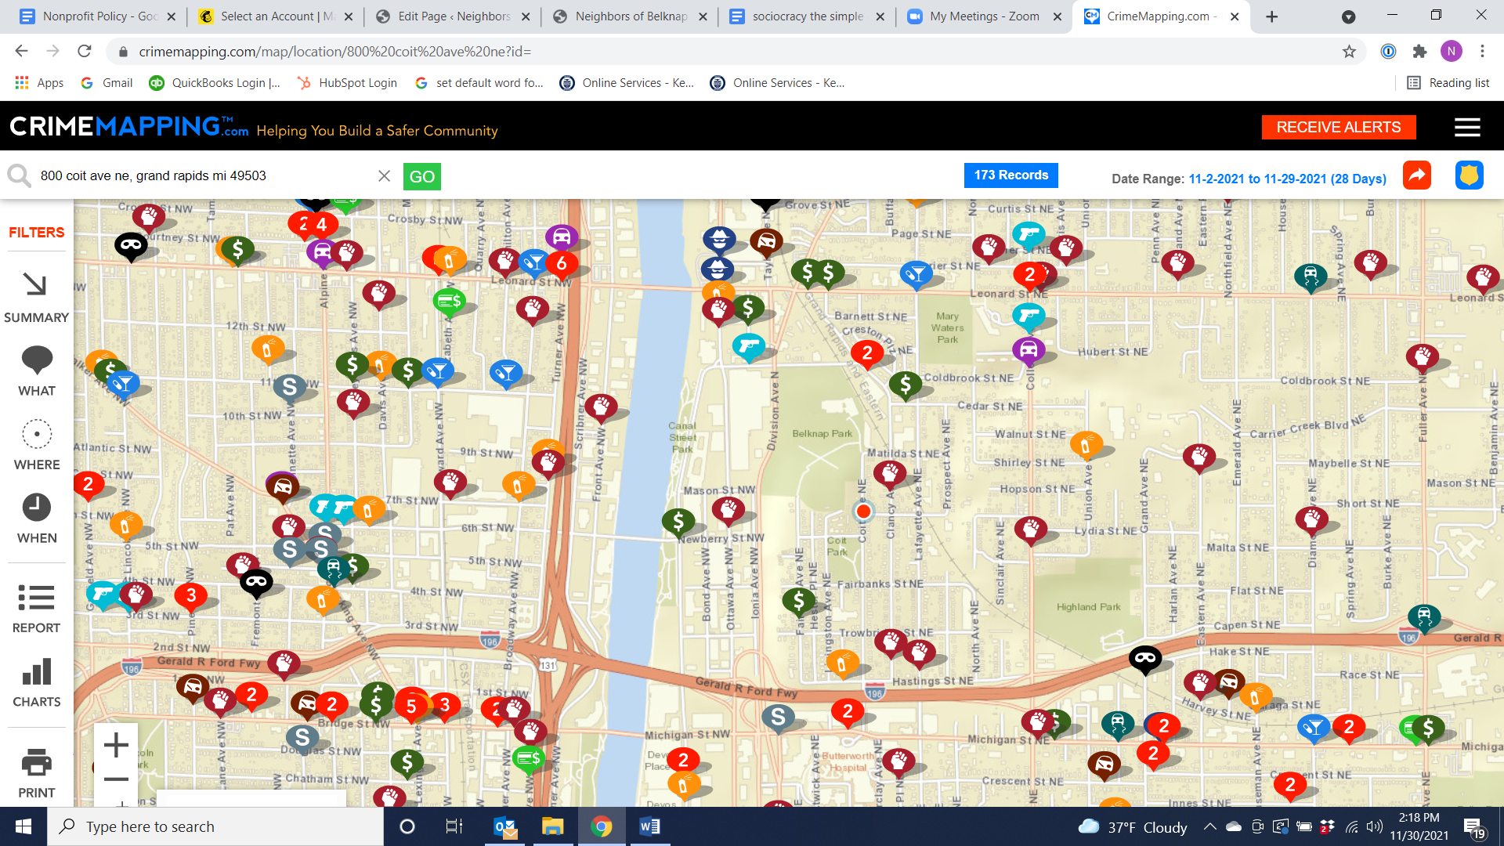

* Permits are in for the Spectrum Health buildings in Monroe North.
* Elianna plans to submit our NMF application for Dispute Resolution Center training with Ben on Saturday 12/18. She also plans to sign a property management agreement with LifeCycles tomorrow.

**Officer Definitions and Duties:** The officers of the NOBL board shall be a chair, vice chair, secretary, and treasurer. As a body they may 1) serve as the small group to handle a temporary change in Executive Director, and 2) be authorized to finalize letters the board has requested to send.

As individuals, the Chair and the Treasurer (as well as the Executive Director) may sign checks; the Chair (and the Executive Director) may sign contracts as directed by the board as well.

1. The Chair may take reports from the Executive Director between meetings and will compile input from the board for the Executive Director’s annual review. The bulk of the Chair’s regular responsibilities have to do with running board meetings, at which he or she will:

* Call the meeting to order at the appointed time and announce items on the agenda in the proper order.
* Recognize those who wish to speak in proper order; protect the rights of the person speaking and maintain decorum.
* Clarify all motions that have been made and seconded, so that all have heard and understand the motion before calling for a vote.
* State definitively and clearly the result of the vote.

The Chair is currently defined in the bylaws as not voting except in the case of a tie; we would like to change that practice by group agreement for the time being and remove that requirement from the bylaws the next time they are updated.

The Chair and the Executive Director may both make public statements (primarily for news media) for the organization and should keep each other informed of what they have said.

B) The Vice Chair should familiar with the duties of the Chairperson and be prepared at all times to assume that office.

C) The Treasurer should work with the Executive Director to determine updates to financial procedures, with a likely goal of reviewing monthly bank statements and financial reports. This individual can also take the lead on the discussion of the financial reports at each board meeting as well as take part in the preparation and presentation of the budget around the end of the year and the 990 after the year end.

D) The Secretary should keep careful and authentic records of development proceedings and all motions. General discussions may be summarized with emphasis on the overall conclusion, and only highlights of the pros and cons discussed. The minutes should be shared with the board, via the Executive Director if desired, within 2 weeks of the meeting.